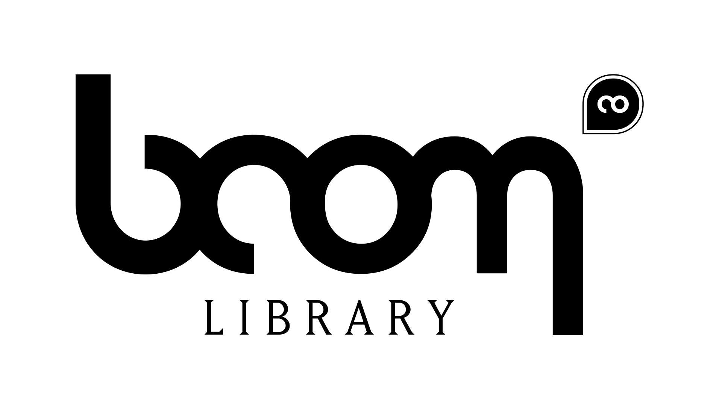

BOOM Library Special Offers:

Sign up to our newsletter to get FREE sounds. Simply go to www.boomlibrary.com and click on the blue “NEWSLETTER-SIGNUP”-Button on our homepage. You will receive a welcome package of great BOOM library sounds. Stay informed!

Looking for group buys or multiuser licenses? Contact us at service@boomlibrary.com to get your special offer!

Do you have a website or a blog? You can feature our products on your website and get great discounts on your own BOOM library purchases.

Send us testimonials and credits of projects that you have worked on using our products. You might end up becoming one of our beta testers – with free copies of brand new BOOM library collections.

Birds Of prey

Installation:

- Copy the files from the DVD to your hard drive
- If the files are packed into one or multiple zip files, decompress the zip file/s
- Import the files to you library management system

Tips and tricks:

Audio Management Systems

We included extensive metadata within the sound files. The metadata is optimized for Soundminer (http://www.soundminer.com). There are lots of good audio management systems out there. Most of them are able to read the description included in the sound files. This, and the name of the files, is the most important information you will need. We strongly recommend using metadata, because it is much more efficient.
In Soundminer you will also find additional information like the designers and microphones used.

Questions? Suggestions? Feedback? Contact us at service@boomlibrary.com.

